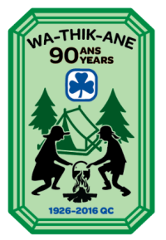
ORDER FORM
Wa-Thik-Ane’s 90th Anniversary Celebration Crests

Camp Wa-Thik-Ane is celebrating its 90th anniversary in 2016. Order this crest for a camp or upcoming commemorative event.

Crests are $3 each (including tax). Please complete this form and email it to: info@guidesquebec.ca

Date:

Guider name:

Guider iMIS:

Guider email address:

Unit/District/Area:

Number of crests:

Please mail the crests to: (Let us know if the crests will be picked up at the office.)

Name: (if different from above)

Mailing Address:

Street:

City: Province:

Postal code:

PAYMENT

We will send you an invoice for the total amount including 5% GST, 9.975% QST and shipping costs.
Payment is accepted by cheque or credit card.

Cheques should be made out to: ‘GGC Québec Council’ and sent to: GGC QC Provincial office, 100 boul. Alexis-Nihon, Suite 270, Saint-Laurent, QC, H4M 2N7

If you would like to pay by credit card, please fill out the details below or phone us at 514-933-5839

Payment by Credit Card: | Credit Card Number
Visa Mastercard | Name on card |  |  | Expiry Date | /

